Universal Bur Blocks
Increase efficiency and organization. The wide color selection allows clinicians to organize their rotary instruments by procedure.
SS White® Universal Bur Blocks are autoclavable and can be used with diamonds, carbides and polishers.
The use of bur blocks minimizes damage to instruments and reduces the likelihood of injury from sharp instruments, while creating ideal procedural organization.
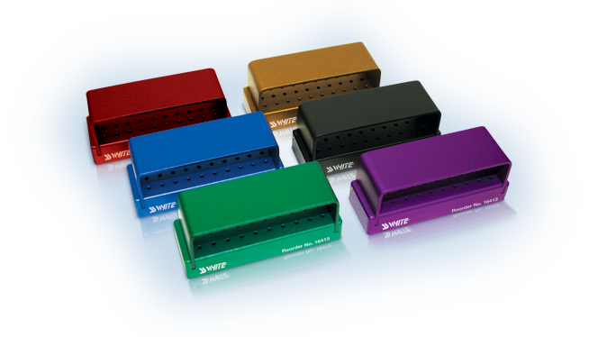
Item #16410 Universal Bur Block – Blue
Item #16411 Universal Bur Block – Bordeaux
Item #16412 Universal Bur Block – Violet
Item #16413 Universal Bur Block – Green
Item #16414 Universal Bur Block – Bronze
Item #16415 Universal Bur Block – Black
Each Universal Bur Block holds the following instruments:
Front row: 10 FG/FGSS/SLFG instruments
Middle row: 10 FG/FGSS/SLFG instruments
Back row: 10 RA/SLRA instruments

